B- PHARMACY

WHAT IS B.COM PHARMACY??

- Bachelor of Pharmacy (B.Pharmacy) is a four-year undergraduate programme that focuses on drug testing and research for a variety of diseases and disorders.
- Pharmacist, Pharmacy Technician, Retail Pharmacist, Pharmacy Manager, and Health Inspector are just a few of the employment available to B.Pharmacy graduates.



- The course covers all aspects of medical care, including biochemistry, drug readiness, and the quantity of drugs that should be recommended to patients for proper treatment.

OVERVIEW OF THE COURSE

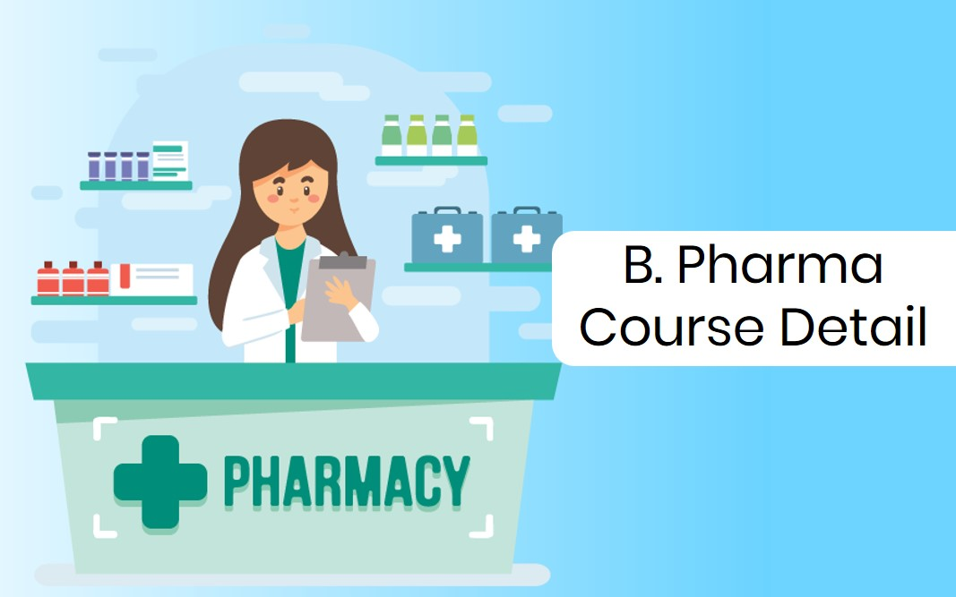

Degree | Bachelors
Full Form | Bachelor of Pharmacy
Duration | Course Duration of Bachelor of Pharmacy [B.Pharm] is 4 Years.
Age | Minimum age limit is 17 years
Minimum Percentage | 50% in 10+2 from a recognised board
Subjects Required | Should have studies Physics, Chemistry and Biology in 10+2
Average Fees Incurred | INR 4 - 10 LPA
Average Salary Offered | INR 2 - 5 LPA

WHY SHOULD YOU OPT FOR B PHARMACY

There are numerous compelling reasons why you should seek a bachelor's degree in pharmacy. Apart from the fact that B Pharmacy will prepare you for a profession as a Medical Representative, Scientific Writing, Medical Scripting, Clinical Research, and so on, we will go over the various benefits of doing this degree in depth.

Government Jobs:You might work for a range of government organisations and hospitals after receiving your bachelor's degree in pharmacy.
Working with Patients: You will play a significant part in the health-care system by providing asthma care, cholesterol testing, diabetic disease management, and bone density testing, among other services.
Various Career Options: Working at a retail pharmacy, whether in a healthcare facility or in the community, is the most apparent option for pharmacists. The job include offering people over-the-counter and prescription drugs, as well as counselling.

FIELDS UNDER THIS COURSE

There are various fields in B Pharmacy. Some of them are as follows
- Pharmaceutical Chemistry
- Pharmaceutical Technology
- Pharmaceutical Analysis and Quality Assurance
- Clinical Pharmacy
- Pharmaceutics
- Pharmacy Practice
- Pharmacognosy
- Pharmacology
- Pharmaceutical Marketing Management
- Quality Assurance
- Phytopharmaceuticals and Natural products
- Drug Discovery and Development
- Medicinal Chemistry
- Bulk Drugs
- Drug Regulatory Affairs
- Biopharmaceutics
- Industrial Pharmacy

CAREER OPPORTUNITIES AFTER GRADUATING B-PHARMACY:-

Job Profiles | Job Description
medical writer | The main responsibility of a medical writer is to interact with doctors and keep track of all medical results, product usage, and medical data.
Clinical Researcher | A clinical researcher collects and analyses information gathered via thorough testing and research.
Drug Inspector | A Drugs Inspector is in charge of overseeing the quality of a drug and issuing licences to other pharmacists.
Medical Representative | They are in charge of marketing numerous drugs for the firm for whom they work. Their work is goal-oriented.
Pharmacy Business | After passing through all of the ethical and legal requirements set out by the monitoring agencies, the main employment responsibility will be to distribute and dispense medications in either retail or wholesale, regionally or across India, while ensuring that safe and proper medicines are delivered to the public.
Hospital Pharmacist | A hospital pharmacist is in charge of medicine dispensing and pharmacy maintenance. Hospital pharmacists are in charge of inventory management and medicine delivery in compliance with physician orders.

WHAT WE CAN DO IN FURTHER/HIGHER AFTER STUDYING THIS COURSE:-
M Pharm Quality Assurance | Pharm.D (Post Baccalaureate) | Master of Pharmacy [M.Pharm] (Pharmaceutics)
Master of Pharmacy [M.Pharm] (Pharmacology) | Ph.D. (Pharmacology) | Master of Business Administration [MBA] (Pharmaceutical Management)
Master of Pharmacy [M.Pharm] | Master of Science [M.Sc] (Pharmaceutical Chemistry) | M.Phil [Pharmaceutics]

WHAT ARE THE ENTRY-LEVEL SALARY PACKAGES & AVERAGE SALARY PACKAGES FOR B PHARMACY?

Job Profiles | Average Salary (INR)
Medical Writer | 4 - 6 LPA
Clinical Researcher | 5 LPA
Drug Inspector | 8 - 14 LPA
Medical Representative | 3 - 6 LPA
Pharmacy Business | 7 - 10 LPA

WANT TO TAKE ADMISSION IN THIS COURSE OF THE BEST COLLEGE BUT HOW?
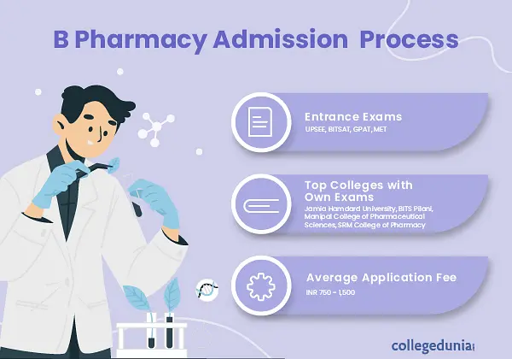

TOP ENTRANCE EXAM FOR B-PHARMACY ARE-
Entrance Exam | Application Dates | About
NEET UG | July 2022 | NEET stands for National Eligibility and Entrance Test, which is an offline test that is used to provide admission to MBBS, BDS, AYUSH, Nursing, and other programmes. Under the 15 percent AIQ and 85 percent State level quota seats, all government and private medical institutions will grant admission. NEET is also the sole test that is accepted for admission to institutes like JIPMER, AIIMS, PGIMER, and others.
PUCET | July 2022 | Punjab University Common Entrance Test (PU CET) is a state-level entrance test held by Punjab University, Chandigarh for students seeking admission to various undergraduate and graduate programmes. Undergraduate courses are tested in PU CET UG, whereas postgraduate courses are tested in PU CET PG.
MHT-CET | February 10, 2022 – March 31, 2022 | The Maharashtra Common Entrance Test is a state-wide test for admission to B.E., B.Tech, and B.Pharm degrees given by government and private universities throughout the state. MHT CET is held once a year, and applicants from different Indian states are welcome to take part.
BITSAT |  | BITS Pilani administers the Birla Institute of Technology and Science Admission Test, a national-level admission exam. Every year, BITSAT is held to give admission to B.E., B.Pharm, M.Sc., and other courses at BITS campuses. Every year, around 3 lakh applicants take the BITSAT.

Top 10 B.Pharmacy Colleges in India
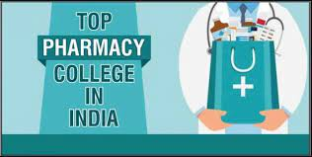
Below is the list of the 10 best B.Pharmacy colleges in India:
Sl.No. | Name of the College
1 | Manipal College of Pharmaceutical Science, Manipal
2 | University Institute of Pharmaceutical Sciences, Chandigarh
3 | Institute of Chemical Technology (ICT), Mumbai
4 | Bombay College of Pharmacy, Mumbai
5 | IIT Varanasi
6 | Birla Institute of Technology, Ranchi
7 | Jamia Hamdard, Delhi
8 | Poona College of Pharmacy, Pune
9 | JSS College of Pharmacy, Mysore
10 | Al Ameen College of Pharmacy, Bangalore

